**Mental Health Monitoring App Using Machine Learning**

By Deepti Agarwal

1. **Problem Statement**

Mental health issues affect millions globally, yet timely and effective support remains inaccessible for many. Traditional mental health services face challenges such as delayed intervention and lack of continuous monitoring. Individuals often struggle to recognize and track their emotional states, leading to untreated conditions. There is a need for a tool that provides real-time mental health monitoring, personalized coping strategies, and timely connections to mental health professionals.

1. **Market/Customer/Business Need Assessment**

The increasing prevalence of mental health issues, coupled with the rising awareness and acceptance of seeking mental health support, has created a significant market need for innovative mental health solutions.

* 1. **Market Need**
* **Growing Prevalence:** Mental health disorders affect a significant portion of the global population, with anxiety and depression being the most common. The World Health Organization estimates that one in four people will be affected by mental or neurological disorders at some point in their lives.
* **Increased Awareness:** There is a growing recognition of the importance of mental health, leading to higher demand for effective mental health services and tools.
* **Digital Health Trend:** The adoption of digital health solutions is on the rise, providing an opportunity for innovative tools to support mental health.
  1. **Customer Need**
* **Continuous Monitoring:** Individuals need tools that can continuously monitor their mental health, providing real-time insights into their emotional states.
* **Personalized Support**: Users require personalized coping strategies tailored to their specific needs and circumstances.
* **Accessibility:** Many people face barriers to accessing traditional mental health services, such as cost, stigma, and geographic limitations. A digital tool can provide accessible support.
* **Early Intervention:** Early detection and intervention can prevent the escalation of mental health issues, making it crucial to have tools that can alert users and professionals to potential problems.
  1. **Business Need**
* **Scalability:** A digital mental health tool can be scaled to reach a large number of users, providing widespread impact.
* **Cost-Effectiveness:** Automated monitoring and support reduce the reliance on one-on-one sessions, making mental health care more affordable.
* **Data-Driven Insights:** Collecting and analyzing data on mental health trends can provide valuable insights for improving mental health services and interventions.
* **Market Opportunity:** The mental health app market is projected to grow significantly, driven by the increasing demand for accessible and effective mental health solutions.

1. **Target Specifications and Characterization (your customer characteristic)**
   1. **Customer Characteristics**
      1. **Primary Users**

* People experiencing stress, anxiety, depression, or other mental health issues who need continuous monitoring and support.
* This demographic is highly engaged with digital solutions and often experiences high levels of stress and anxiety.
* Individuals with high-stress jobs looking for convenient ways to monitor and manage their mental health.
  + 1. **Secondary Users**
* Therapists and counselors who can use the tool to monitor their clients’ mental health trends and provide timely interventions.
* People supporting individuals with mental health issues who need tools to help monitor their loved ones' emotional well-being.
  1. **Target Specifications**
* **User-Friendly Interface:** An intuitive design with mobile accessibility for easy, anytime access.
* **Real-Time Monitoring:** Accurate sentiment analysis and mood prediction based on user interactions.
* **Personalized Recommendations:** Tailored coping strategies and resource suggestions.
* **Connectivity with Professionals:** A directory of mental health professionals and an alert system for significant mood changes.
* **Privacy and Security:** Anonymized data and robust security measures to protect user information.
* **Customizable Settings:** Options for personalized notification preferences and detailed user profiles.

1. **External Search**

For external search and references related to developing a "Mental Health Monitoring Tool" focusing on sentiment analysis, mood prediction, and mental health support, consider the following reputable sources and links:

1. **Sentiment Analysis and Mood Prediction:**
   * Introduction to Sentiment Analysis: [Stanford NLP Sentiment Analysis](https://nlp.stanford.edu/sentiment/)
   * Overview of Mood Prediction Techniques: [Predicting Mood Disorders](https://www.ncbi.nlm.nih.gov/pmc/articles/PMC6179571/)
2. **Mental Health Monitoring and Support Tools:**
   * Overview of Digital Mental Health Tools: Digital Mental Health Tools
   * Evaluation of Mental Health Apps: [Evaluation of Mental Health Apps](https://www.ncbi.nlm.nih.gov/pmc/articles/PMC7287997/)
3. **Privacy and Security in Health Apps:**
   * Guidelines for Data Privacy in Health Apps: Privacy in Health Apps
   * Security Considerations for Mobile Health Apps: Security in Mobile Health Apps
4. **User Interface Design and Accessibility:**
   * Principles of User Interface Design: User Interface Design Basics
   * Accessibility Guidelines for Mobile Apps: [Mobile App Accessibility](https://developer.apple.com/design/human-interface-guidelines/accessibility/overview/introduction/)

These resources provide foundational knowledge, research insights, and best practices for developing a robust "Mental Health Monitoring Tool" that integrates sentiment analysis, mood prediction, personalized support, and ensures user privacy and accessibility.

1. **Bench Marking Alternate Products**

**Example Product : Moodpath**

* + **Characteristics:** The app provides daily mood monitoring, customized mental health tips, and activities rooted in cognitive behavioral therapy (CBT).
  + **User Interface:** The app has received favorable ratings on app stores for its easy-to-use layout and tailored suggestions.
  + **Data Protection:** The app complies with GDPR regulations and employs robust data encryption and anonymization methods.
  + **Efficacy:** Clinical research supports the app's ability to enhance mood management and user involvement.
  + **Professional Incorporation:** The app offers limited direct interaction with therapists and emphasizes self-guided assistance.
  + **Pricing:** The app follows a freemium model, offering basic features for free and a premium subscription for full access.

1. **Business Model**
   1. **Subscription Model:**
   * Offer a freemium model with basic features available for free.
   * Charge a subscription fee for access to premium features such as advanced analytics, personalized recommendations, and unlimited professional consultations.
   1. **Transaction Fees:**
   * Implement a revenue-sharing model with mental health professionals.
   * Charge a transaction fee for each consultation facilitated through the platform, providing an additional revenue stream while offering value to users seeking professional support.
   1. **Corporate Partnerships:**

* Form partnerships with employers and organizations interested in promoting mental health and well-being among their employees or members.
* Offer customized versions of the tool as an employee benefit, leveraging bulk subscription deals or corporate wellness programs.
  1. **Premium Features and Upgrades:**
* Introduce additional premium features or upgrades, such as access to specialized therapy modules, mindfulness exercises, or personalized coaching sessions.
* Charge one-time fees or subscription upgrades for these enhanced functionalities, catering to users seeking more comprehensive mental health support.

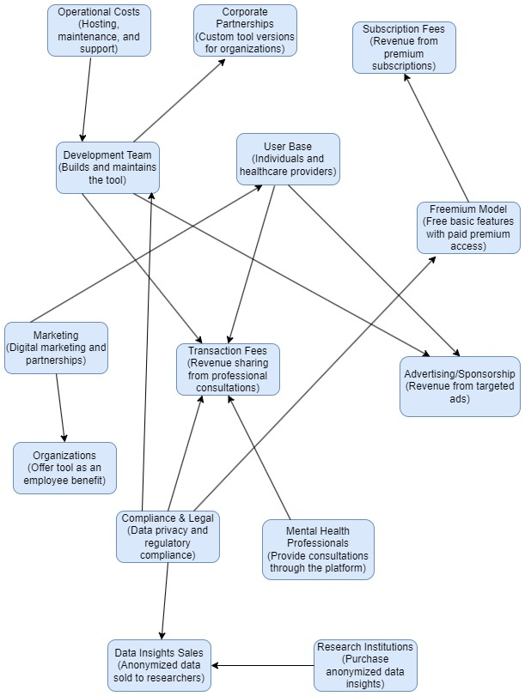**Diagram for Business Model**

1. **Final Product Prototype**

The "Mental Health Monitoring Tool" is an innovative digital platform designed to empower individuals in monitoring and managing their mental health effectively. Leveraging advanced machine learning algorithms, the tool offers real-time sentiment analysis and mood prediction based on user interactions and self-reported data. This enables personalized insights into emotional well-being, aiding users in identifying patterns and trends in their mental health.

**7.1 Diagram for Final Prototype**

User

(Inputs text, mood logs, self-reports)

User Interface

(Mobile/web interface for user interaction)

Personalized Recommendations

(Generates coping strategies and resources)

Sentiment Analysis

(Analyzes text inputs to determine emotional structures)

Mood Prediction

(Uses historical data to predict future moods)

Data Storage

(Stores user data securely)

Professional Connectivity

(Connects users with mental health professionals)

Privacy & Security

(Ensures data privacy and compliance)

* 1. **Key Features:**
* Analyzes text inputs (e.g., journal entries, mood logs) to determine emotional states and trends over time.
* Predicts user moods based on historical data, helping anticipate and manage fluctuations in emotional well-being.
* Offers tailored coping strategies, self-care techniques, and mental health resources based on mood analysis.
* Facilitates connections with mental health professionals for consultations and interventions when needed.
  1. **User Interface:**

The platform features an intuitive user interface accessible via mobile and web applications. Users can input text data, track mood changes, and receive real-time feedback and recommendations. The interface includes customizable settings for notifications, privacy preferences, and profile management, ensuring a personalized user experience.

1. **Product Details for the "Mental Health Monitoring Tool**

**8.1 How Does It Work?**

The "Mental Health Monitoring Tool" operates through a structured process aimed at providing personalized mental health insights and support:

* Users input data through text entries, mood logs, and self-reported assessments via the mobile or web interface.
* Text data undergoes sentiment analysis using natural language processing (NLP) techniques to determine emotional states (positive, negative, neutral).
* Historical data combined with sentiment analysis results are processed using machine learning algorithms (e.g., recurrent neural networks) to predict future mood trends.
* Based on mood predictions and historical patterns, the tool generates personalized coping strategies, self-care techniques, and mental health resources.
* Users can connect with mental health professionals through the platform for consultations, interventions, and personalized support when required.

**8.2 Data Sources**

* Text entries, mood logs, and self-reported assessments provided by users.
* Optionally integrate external data sources such as weather conditions, physical activity logs, or social media sentiments for enhanced context and accuracy.

**8.3 Algorithms, Frameworks, Software, etc. Needed**

* **Algorithms:** Sentiment analysis (e.g., sentiment analysis algorithms using NLP techniques like VADER, TextBlob), mood prediction (e.g., machine learning models like LSTM, GRU for time-series analysis).
* **Frameworks:** Python-based frameworks like TensorFlow, PyTorch for machine learning implementation; Flask or Django for web development; Docker for containerization.
* **Software:** Database management systems (e.g., PostgreSQL, MongoDB), cloud computing services (e.g., AWS, Google Cloud Platform) for scalability and data processing.

**8.5 Cost**

* **Development Costs:** Initial development costs vary based on team size, technology stack, and complexity.
* **Operational Costs:** Ongoing costs include hosting, maintenance, software updates, and customer support.
* **Additional Costs:** Marketing, compliance (e.g., GDPR, HIPAA), and potential costs associated with data anonymization and security measures.

1. **Code Implementation**
   1. **Loading Data**

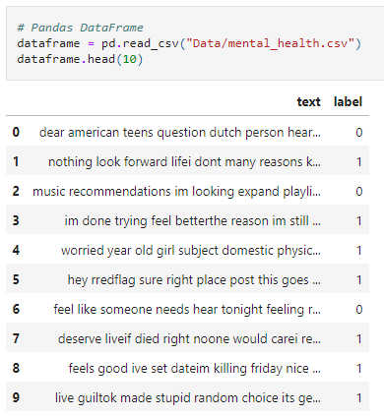

* 1. **Visualizations**

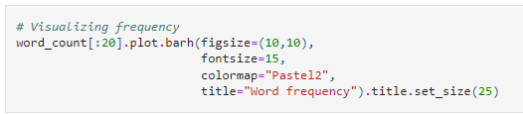

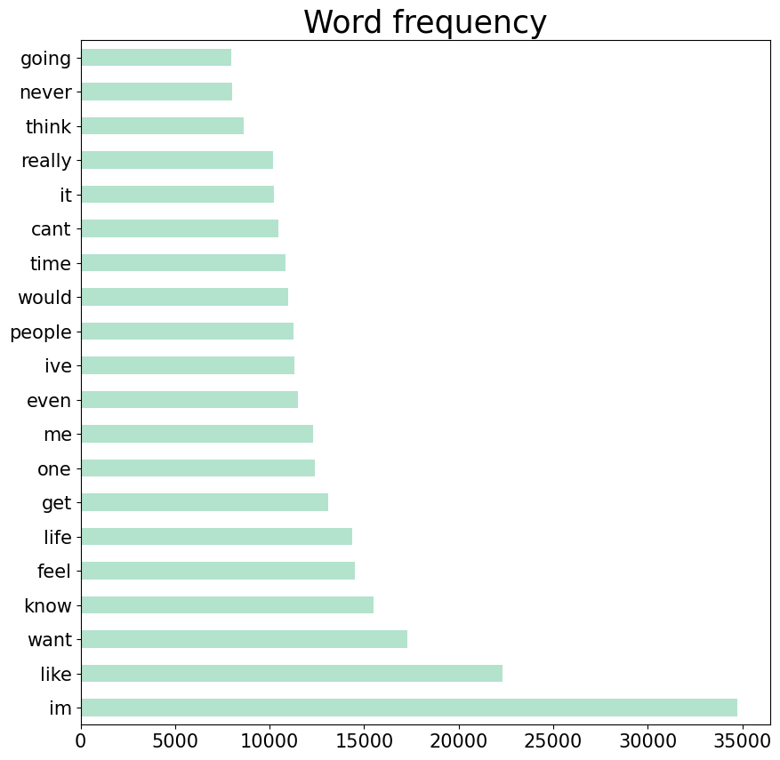

* 1. 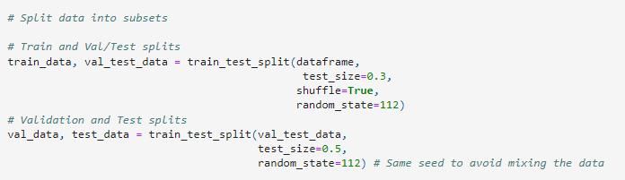**Split Data**
  2. **Sentence length distribution**

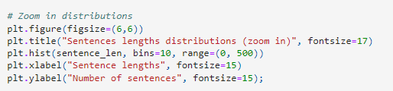

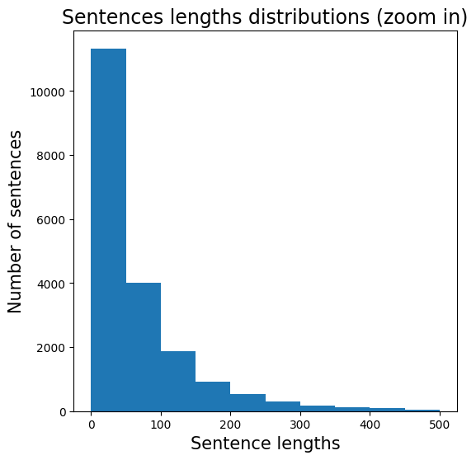

* 1. **Dense Model**

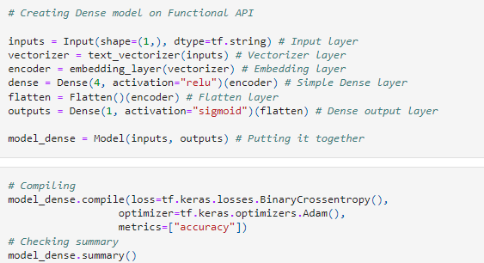

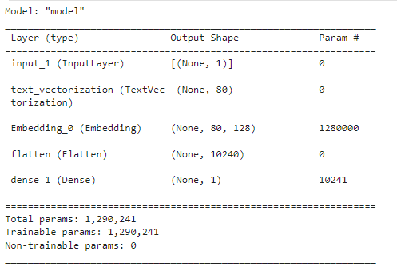

* 1. **LSTM Model**

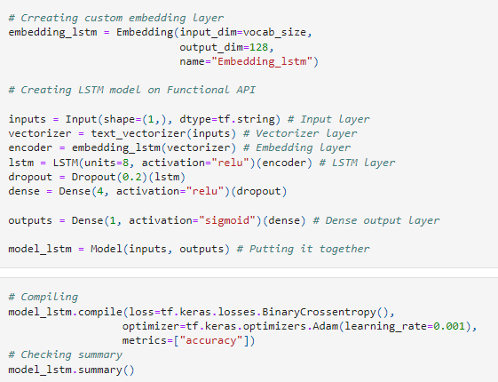

* 1. **Confusion Matrices**

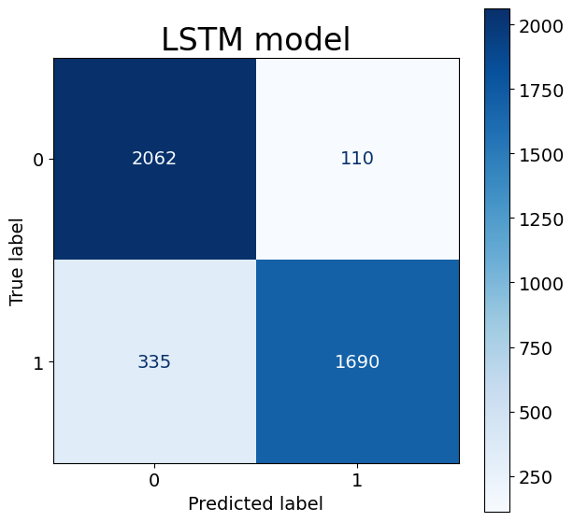

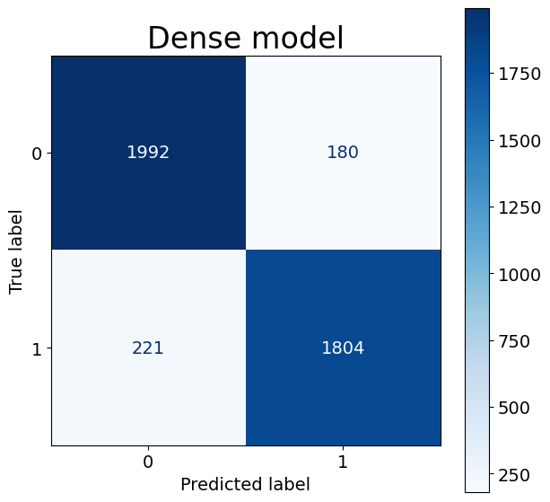

* 1. **Evaluating Model**

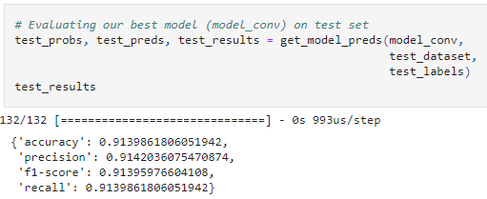

1. **Conclusion**

The "Mental Health Monitoring Tool" leverages advanced technology to provide personalized mental health support. It analyzes user data through sentiment analysis and machine learning algorithms to predict moods and offer customized coping strategies. By facilitating connections with mental health professionals when necessary, the tool aims to improve emotional well-being effectively and securely, emphasizing user privacy and regulatory compliance throughout its development and operation.